Most Abundant Bug

**What is a Bug ?**

A software bug is an error, flaw or fault in the design, development, or operation of computer software that causes it to produce an incorrect or unexpected result, or to behave in unintended ways.

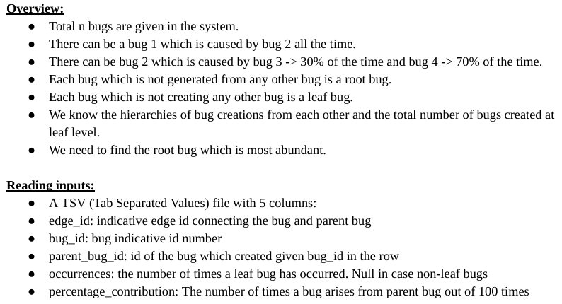

**Sample Input TSV:**

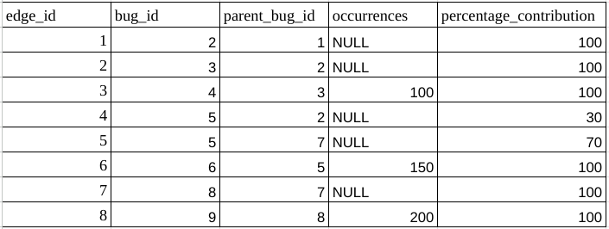In the above example,

Output :

Most abundant bug is 7 with 305 occurrences

[Test Case Input](https://docs.google.com/spreadsheets/d/1jjo3BXlO4LrSfwaOIU0f7j1hZhca9h4BmXZn-DJbBn4/edit#gid=0)

**Assumptions on inputs tsv:**

1. There will be no cycles in bugs stack. For eg., bug 1 is created from bug 2 and bug 2 is created from bug 1 can never be possible.
2. Each bug occurrence percentage_contribution from parent bugs will add up to 100. Example is bug 5 in the above taken example.

**Tree structure in above taken example for reference:**



**Test Case :**

Input :

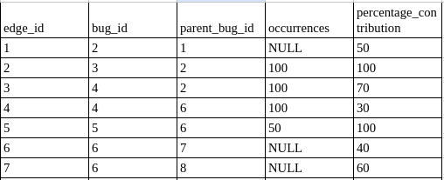

[Test Case Input](https://docs.google.com/spreadsheets/d/1jjo3BXlO4LrSfwaOIU0f7j1hZhca9h4BmXZn-DJbBn4/edit#gid=1566946261)

Diagram :

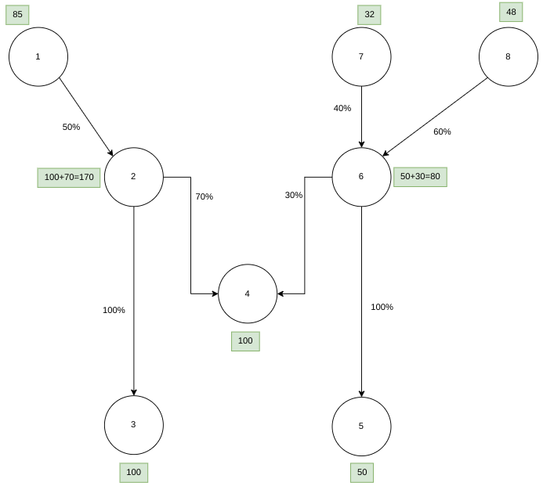

Output :

Most abundant bug is 2 with 170 occurrences

**What is required in the submission?**

* Code in Google Doc (Format should be : Name_RollNumber.docx) (should have public access)
* Mention all the test cases that you can think of.
* Mention the time & space complexity of your solution.
* Screen recording where you’re explaining the code as well as execution of all the test cases. (Google drive link with public access). You can use <https://recordscreen.io/> to record your screen.